SCREENSHOTS FOR MY CLASSWORK BASED ON DATA FUNCTIONS

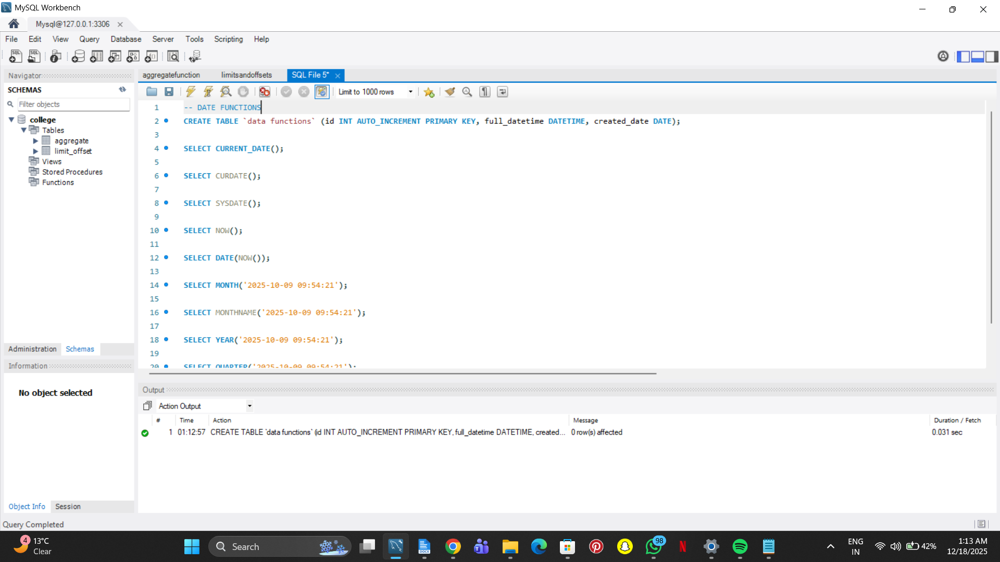

SELECT CURRENT_DATE();

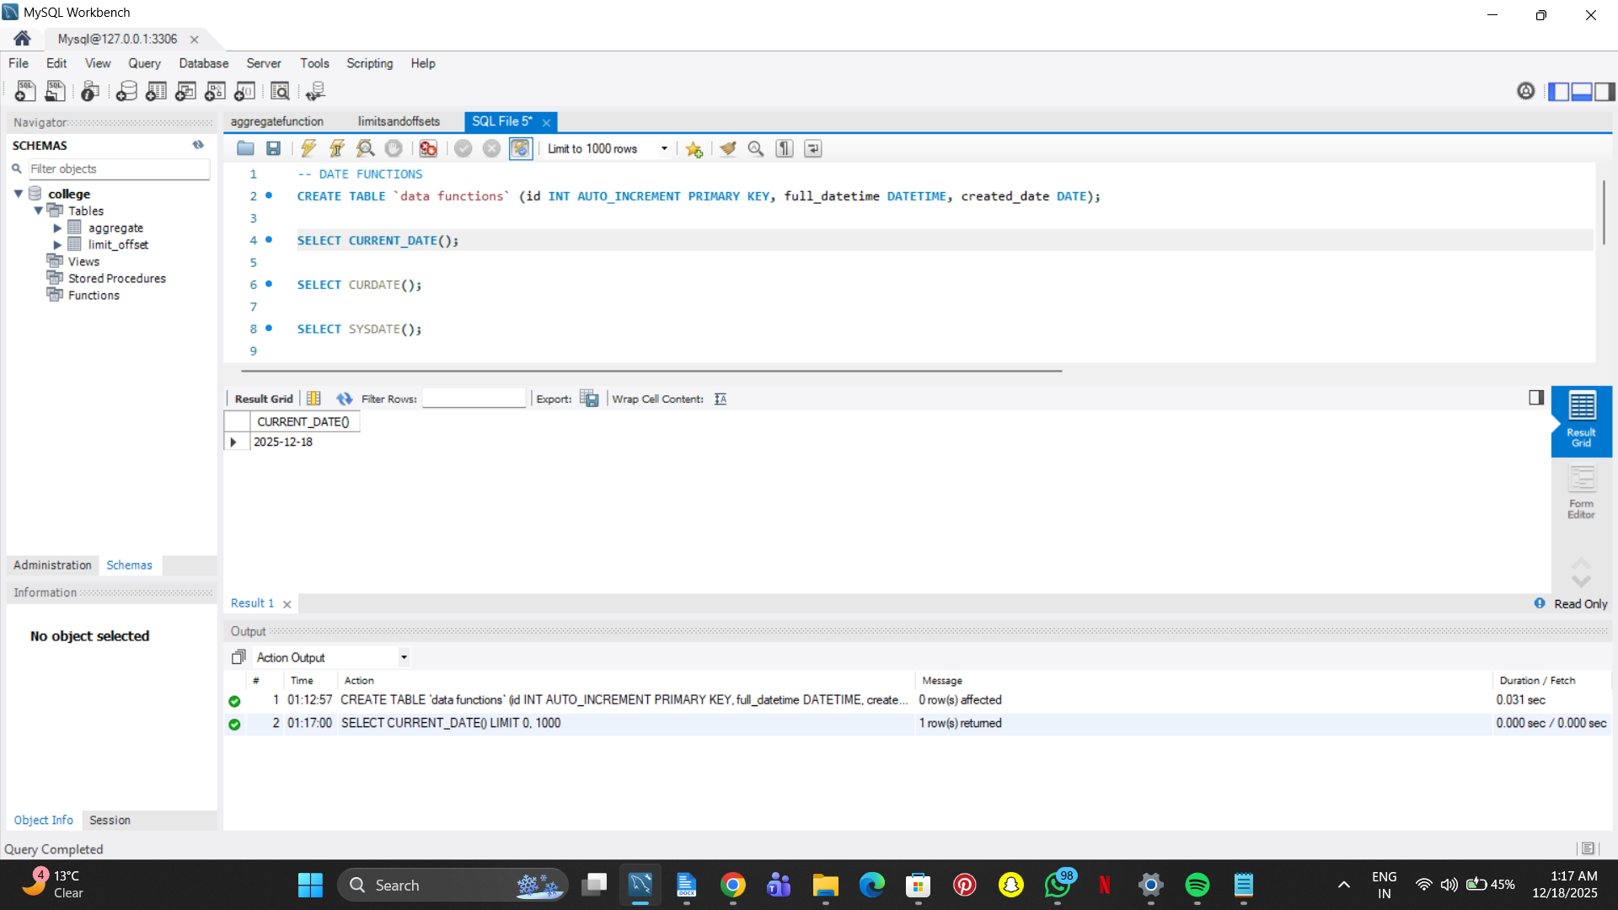

SELECT CURDATE();

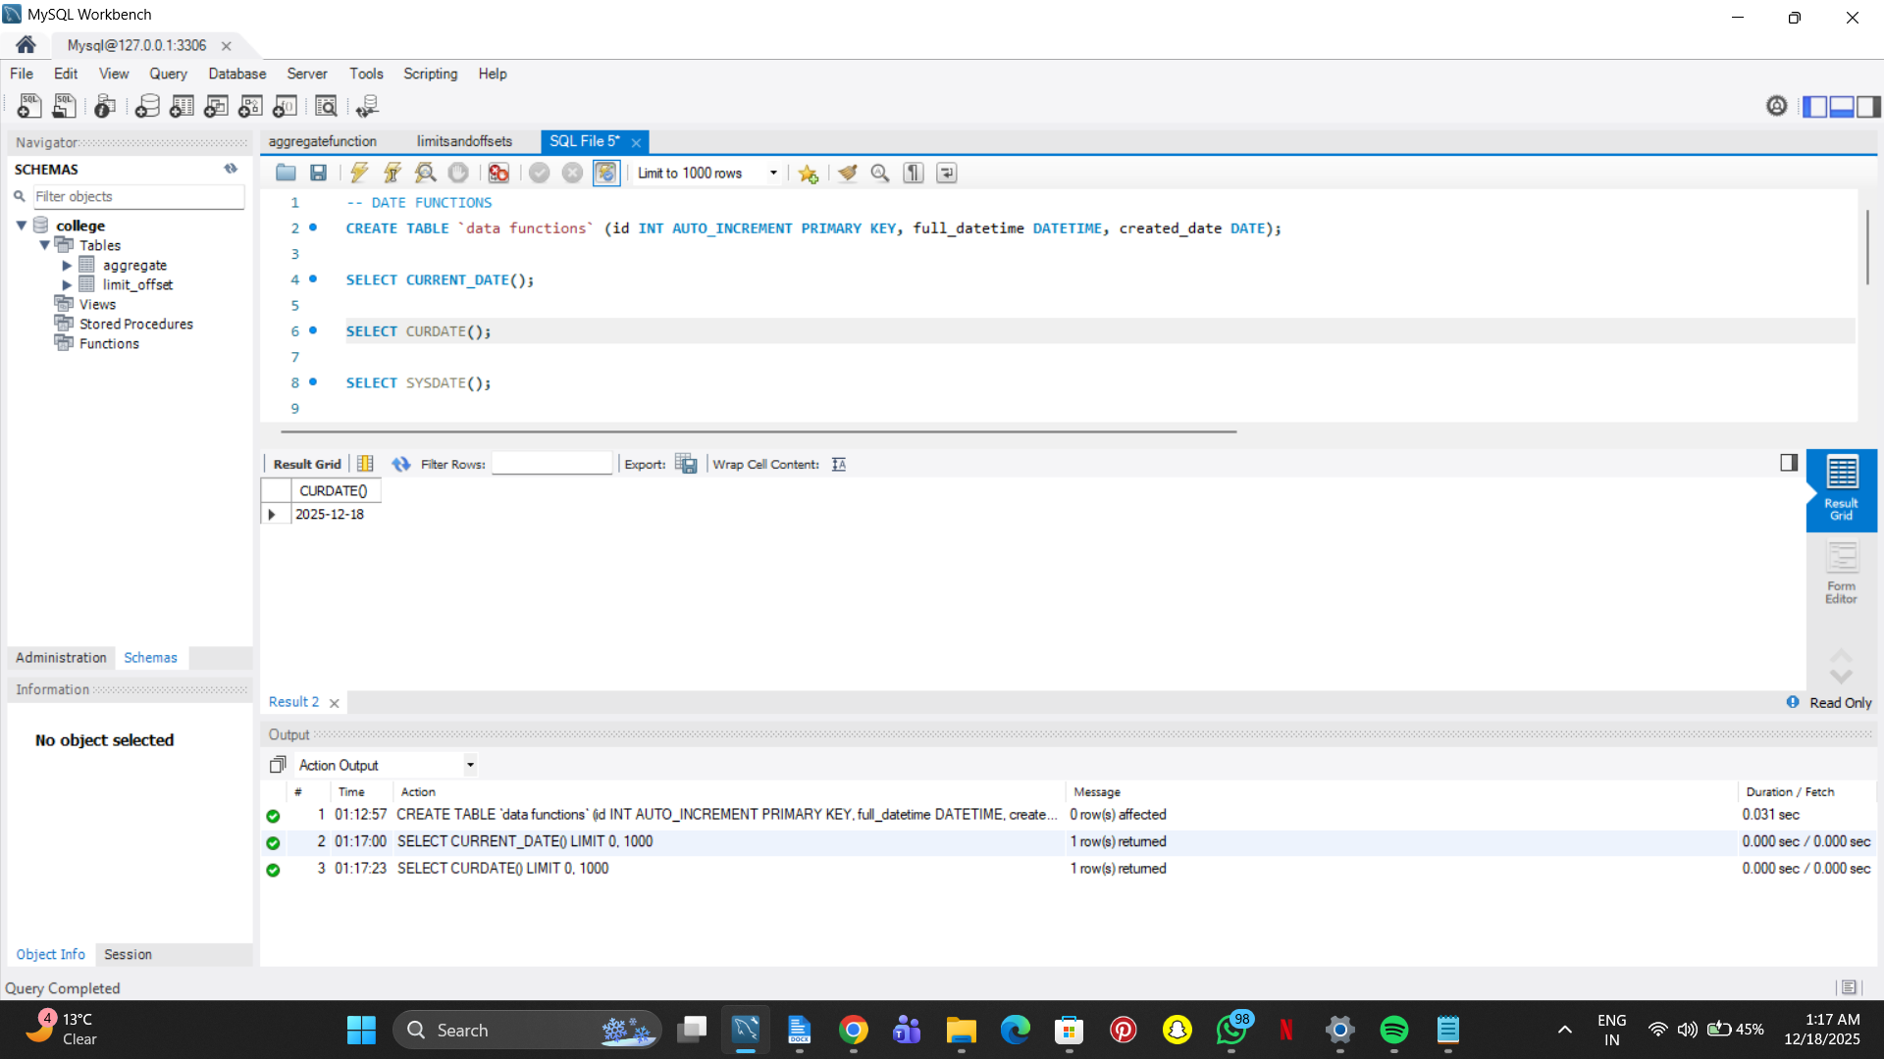

SELECT SYSDATE();

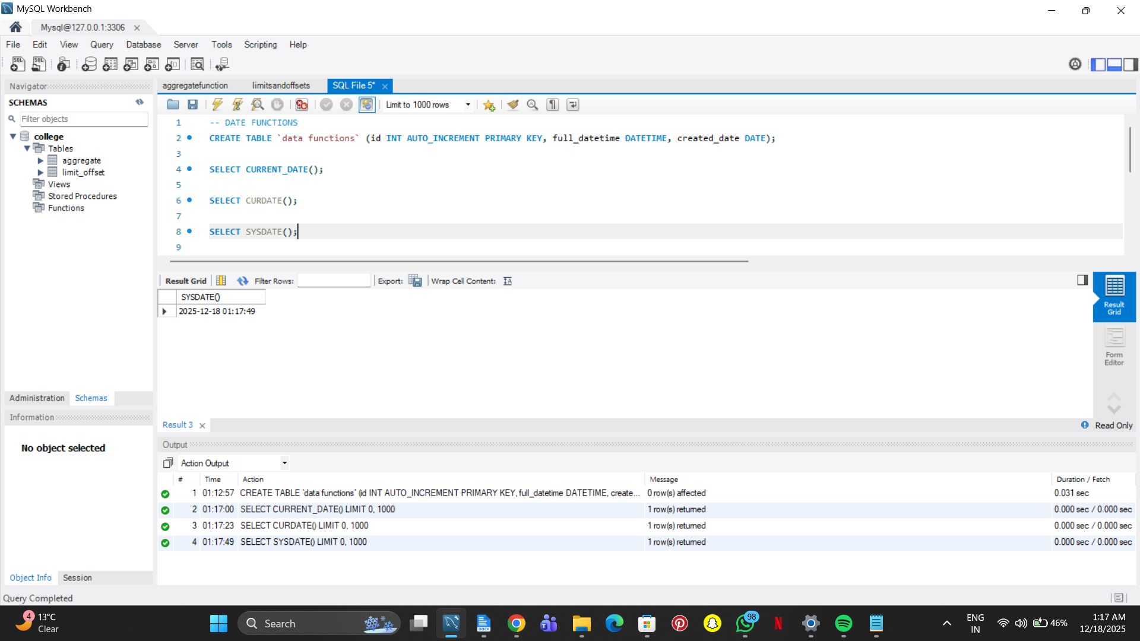

SELECT NOW();

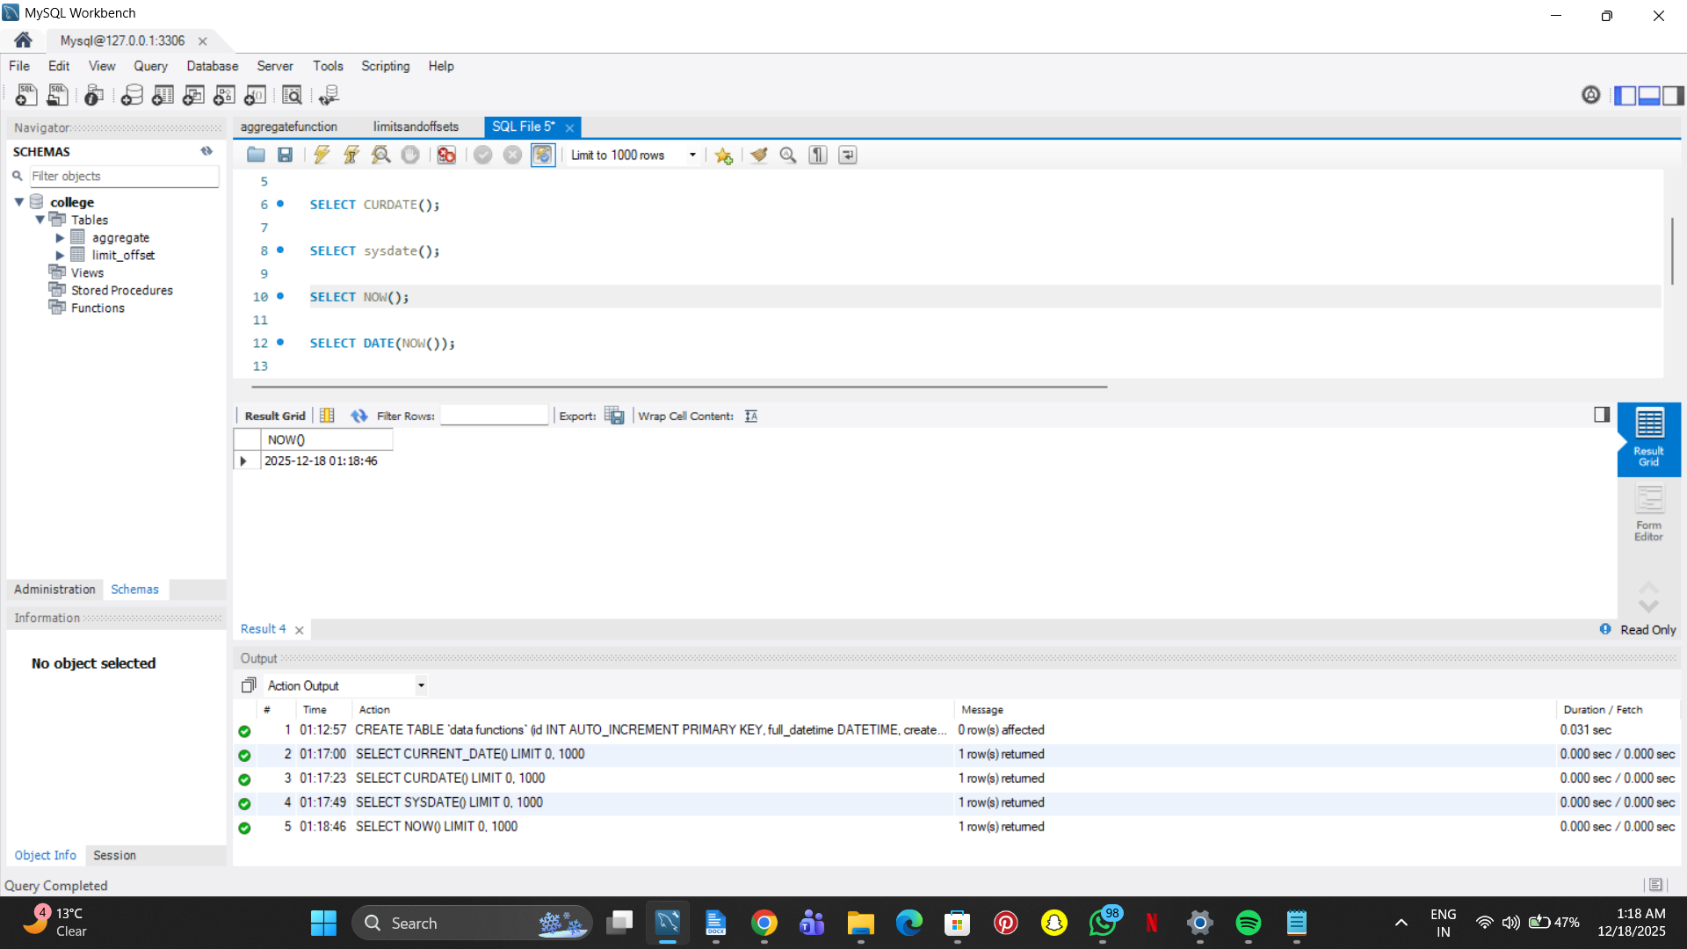

SELECT DATE(NOW());

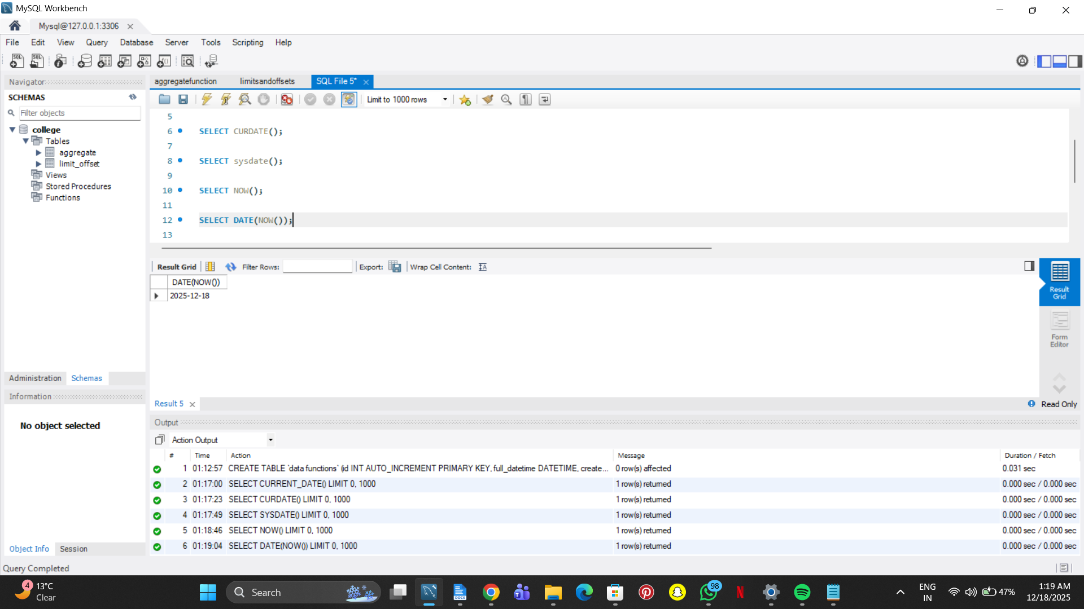

SELECT MONTH('2025-10-09 09:54:21');

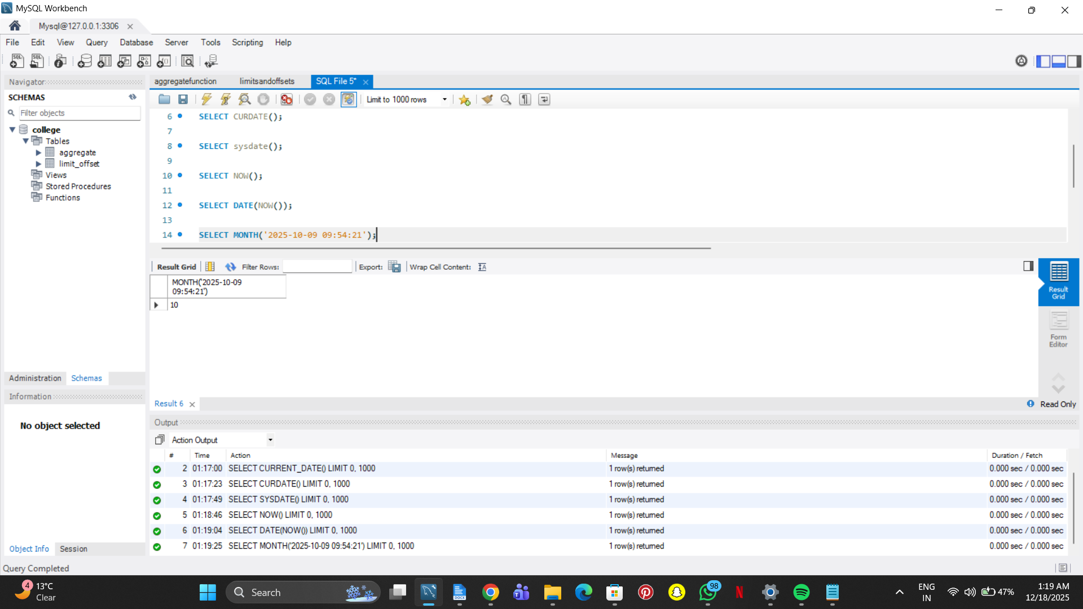

SELECT MONTHNAME('2025-10-09 09:54:21');

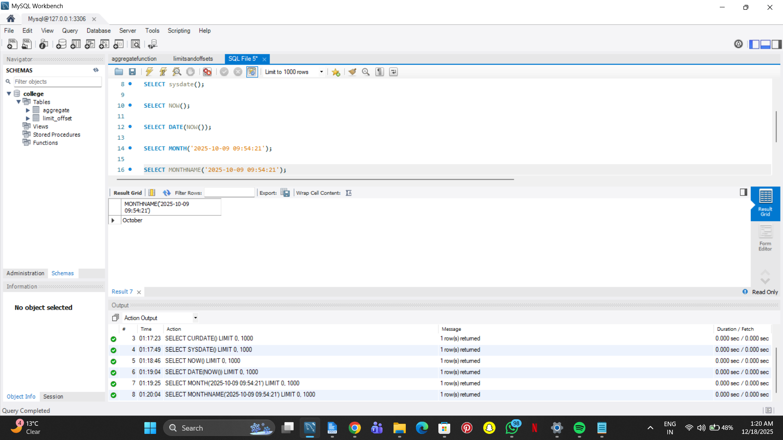

SELECT YEAR('2025-10-09 09:54:21');

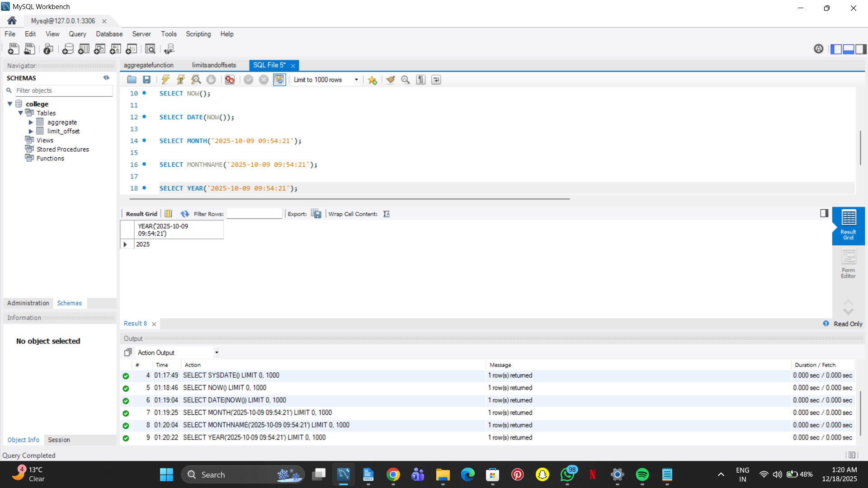

SELECT QUARTER('2025-10-09 09:54:21');

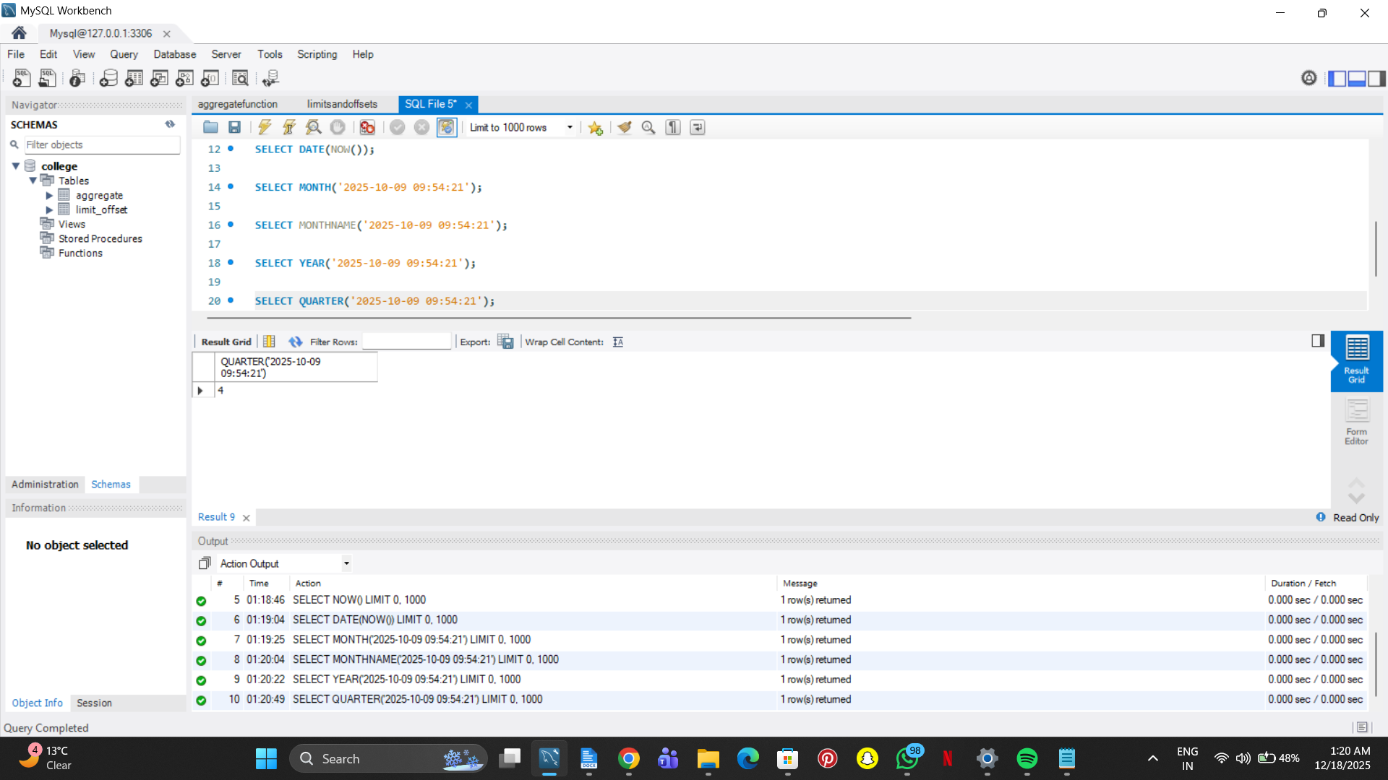

SELECT DAY('2025-10-09 09:54:21');



-- DAY & WEEK DATE FUNCTIONS

SELECT DAYNAME('2025-10-09 09:54:21');

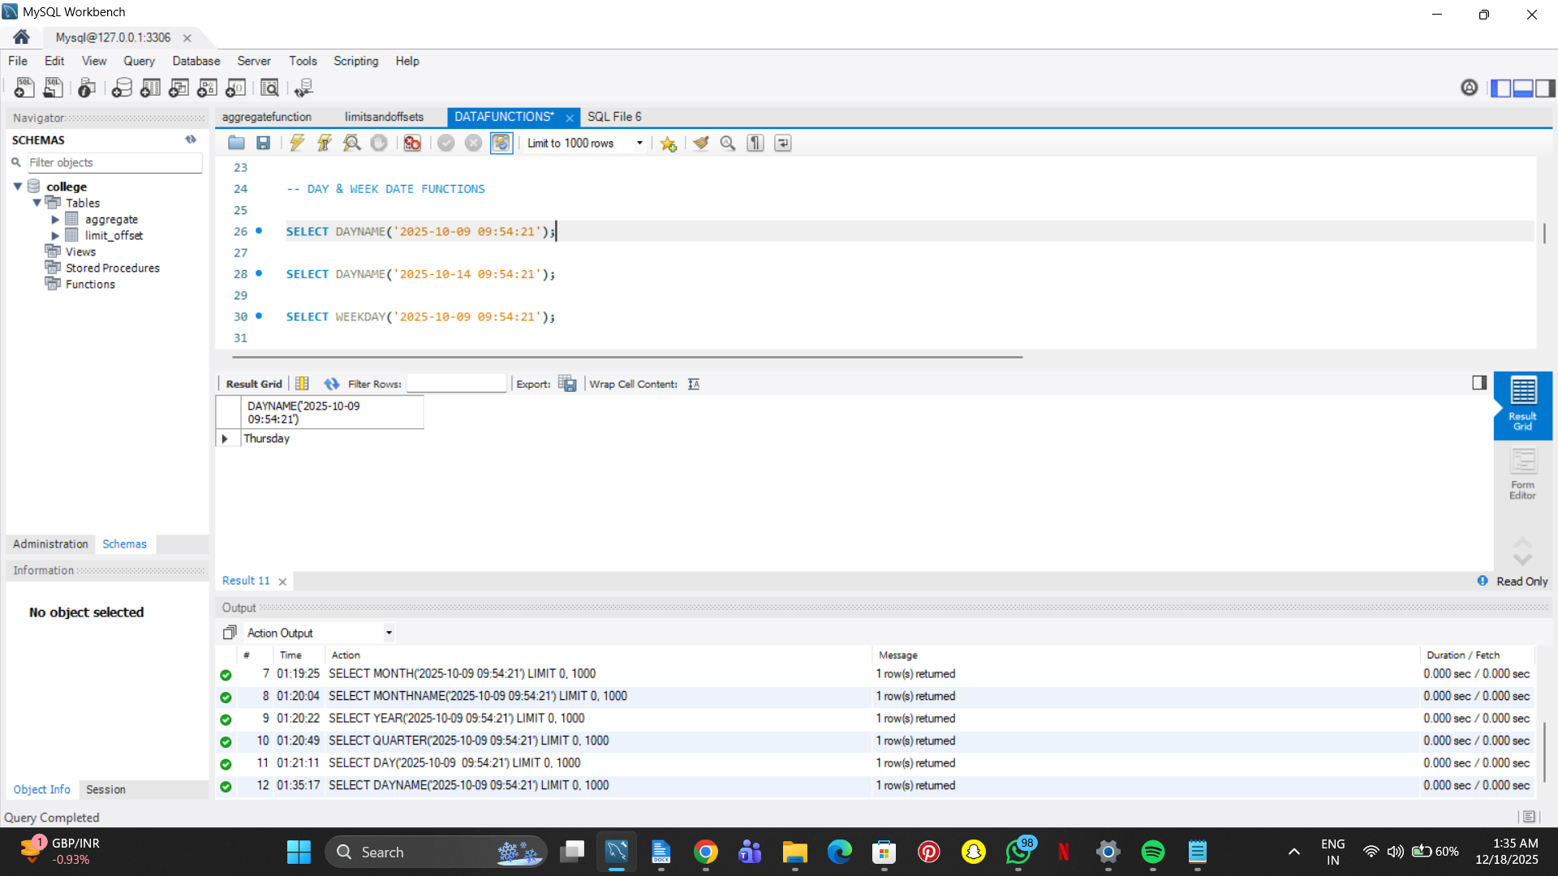

SELECT DAYNAME('2025-10-14 09:54:21');

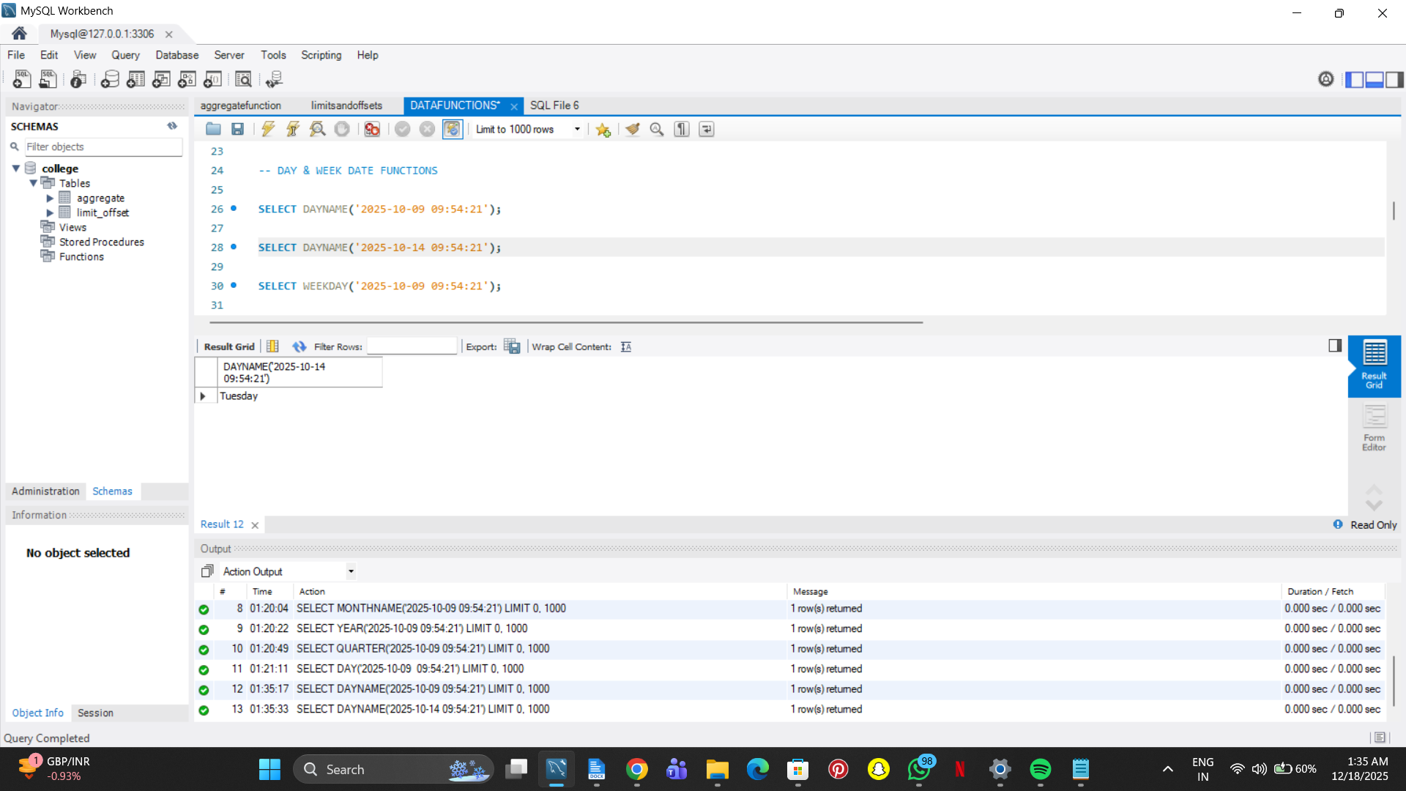

SELECT WEEKDAY('2025-10-09 09:54:21');

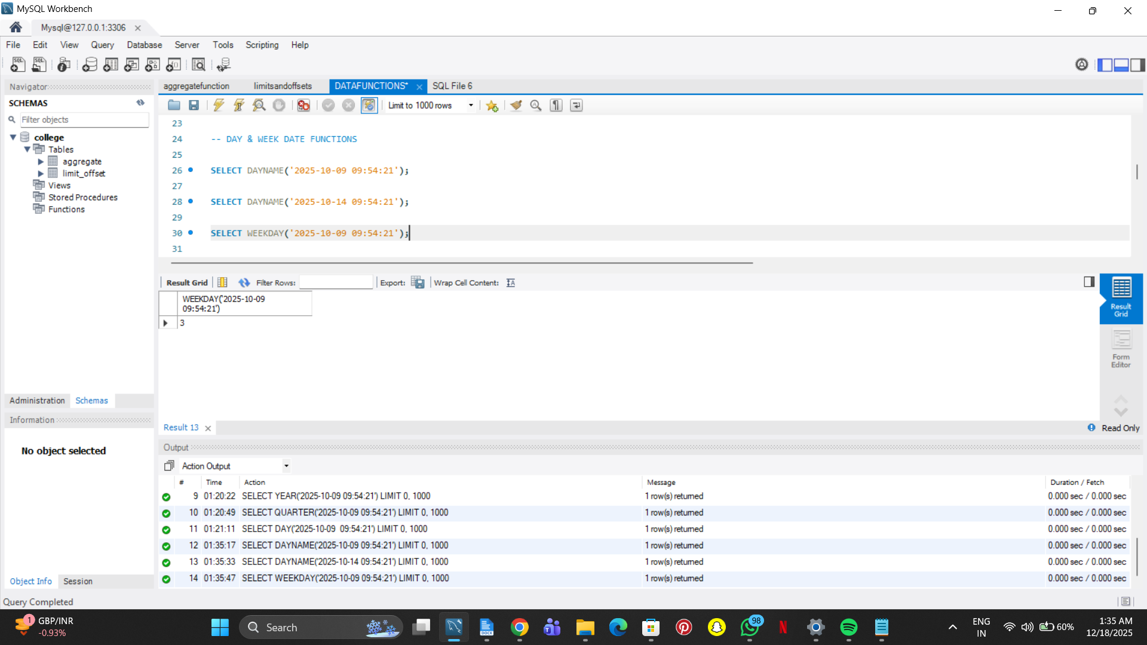

SELECT DAYOFWEEK('2025-10-09 09:54:21');

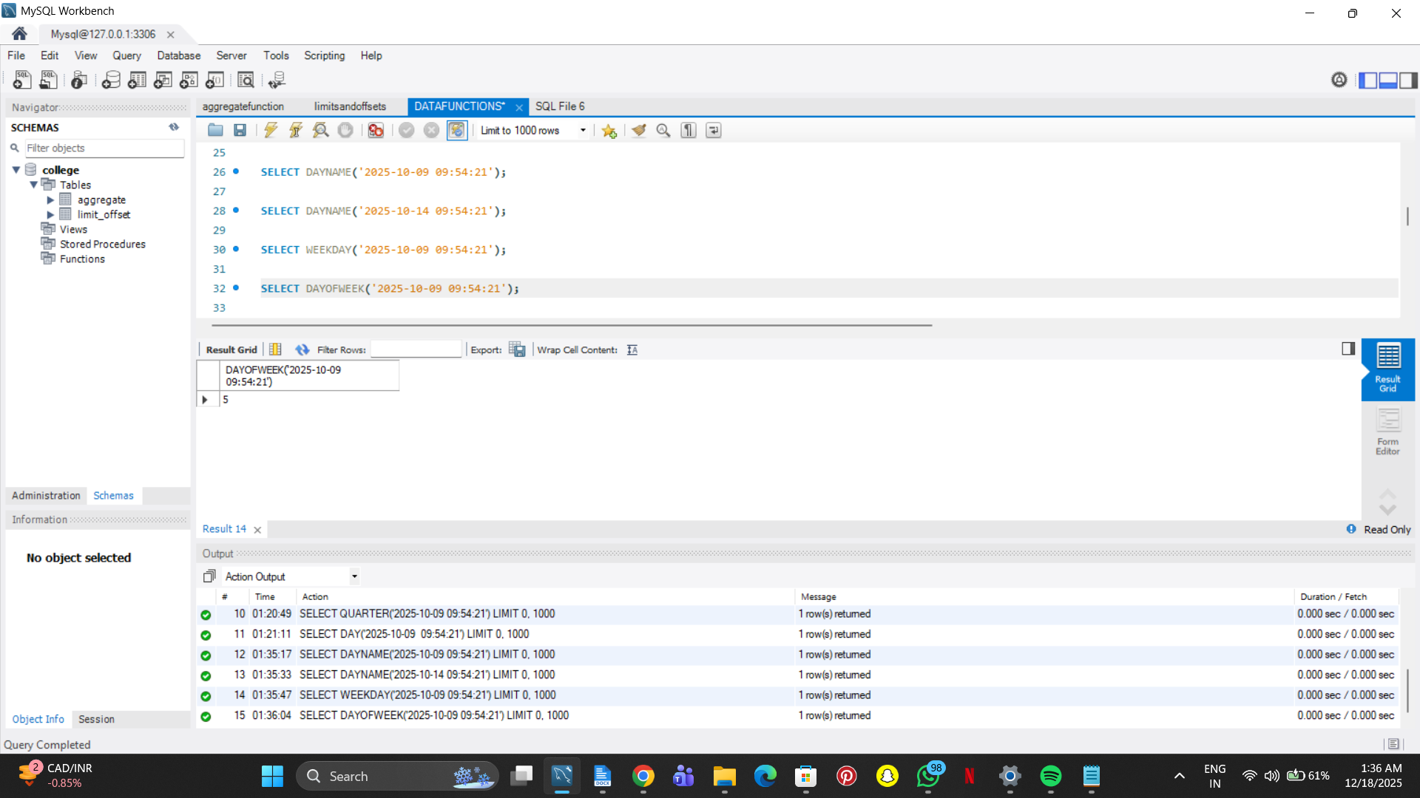

SELECT DAYOFWEEK('2025-10-14 08:57:00');

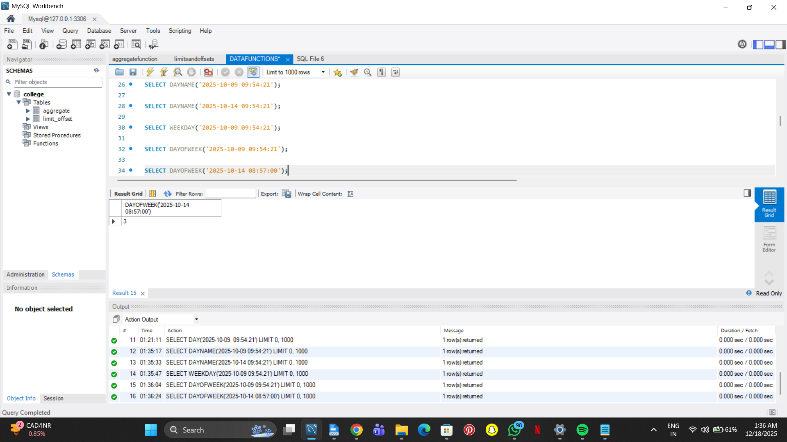

SELECT DAYOFYEAR('2025-10-09 09:54:21');

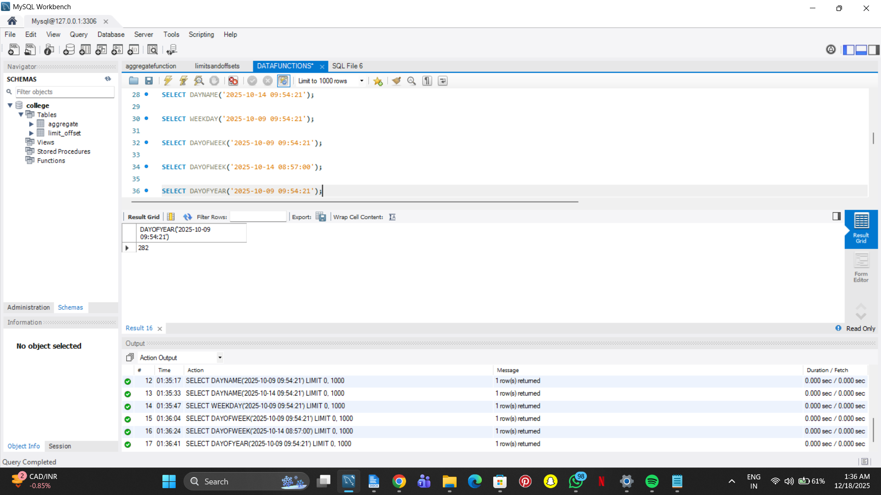

SELECT WEEK('2025-10-09 09:54:21');

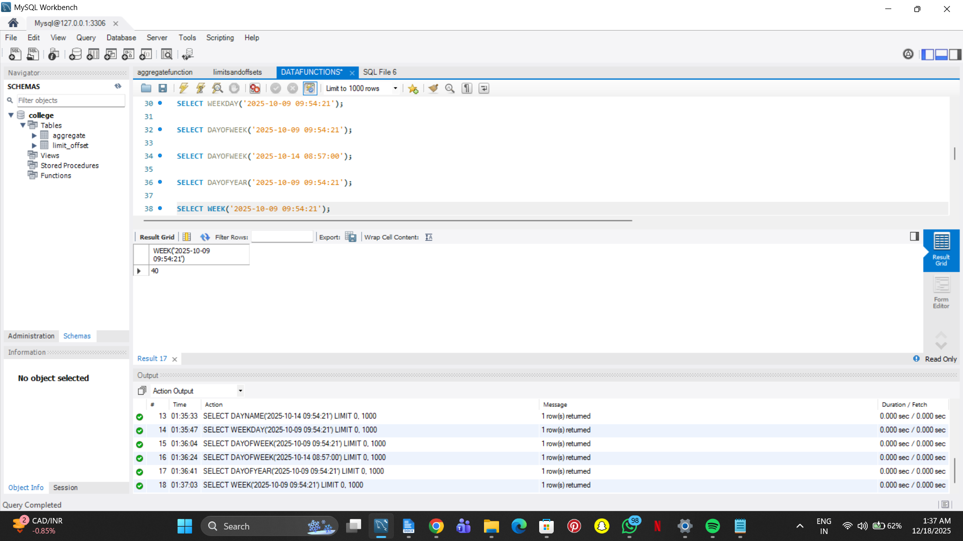

SELECT WEEKDAY('2025-10-14 12:19:00');

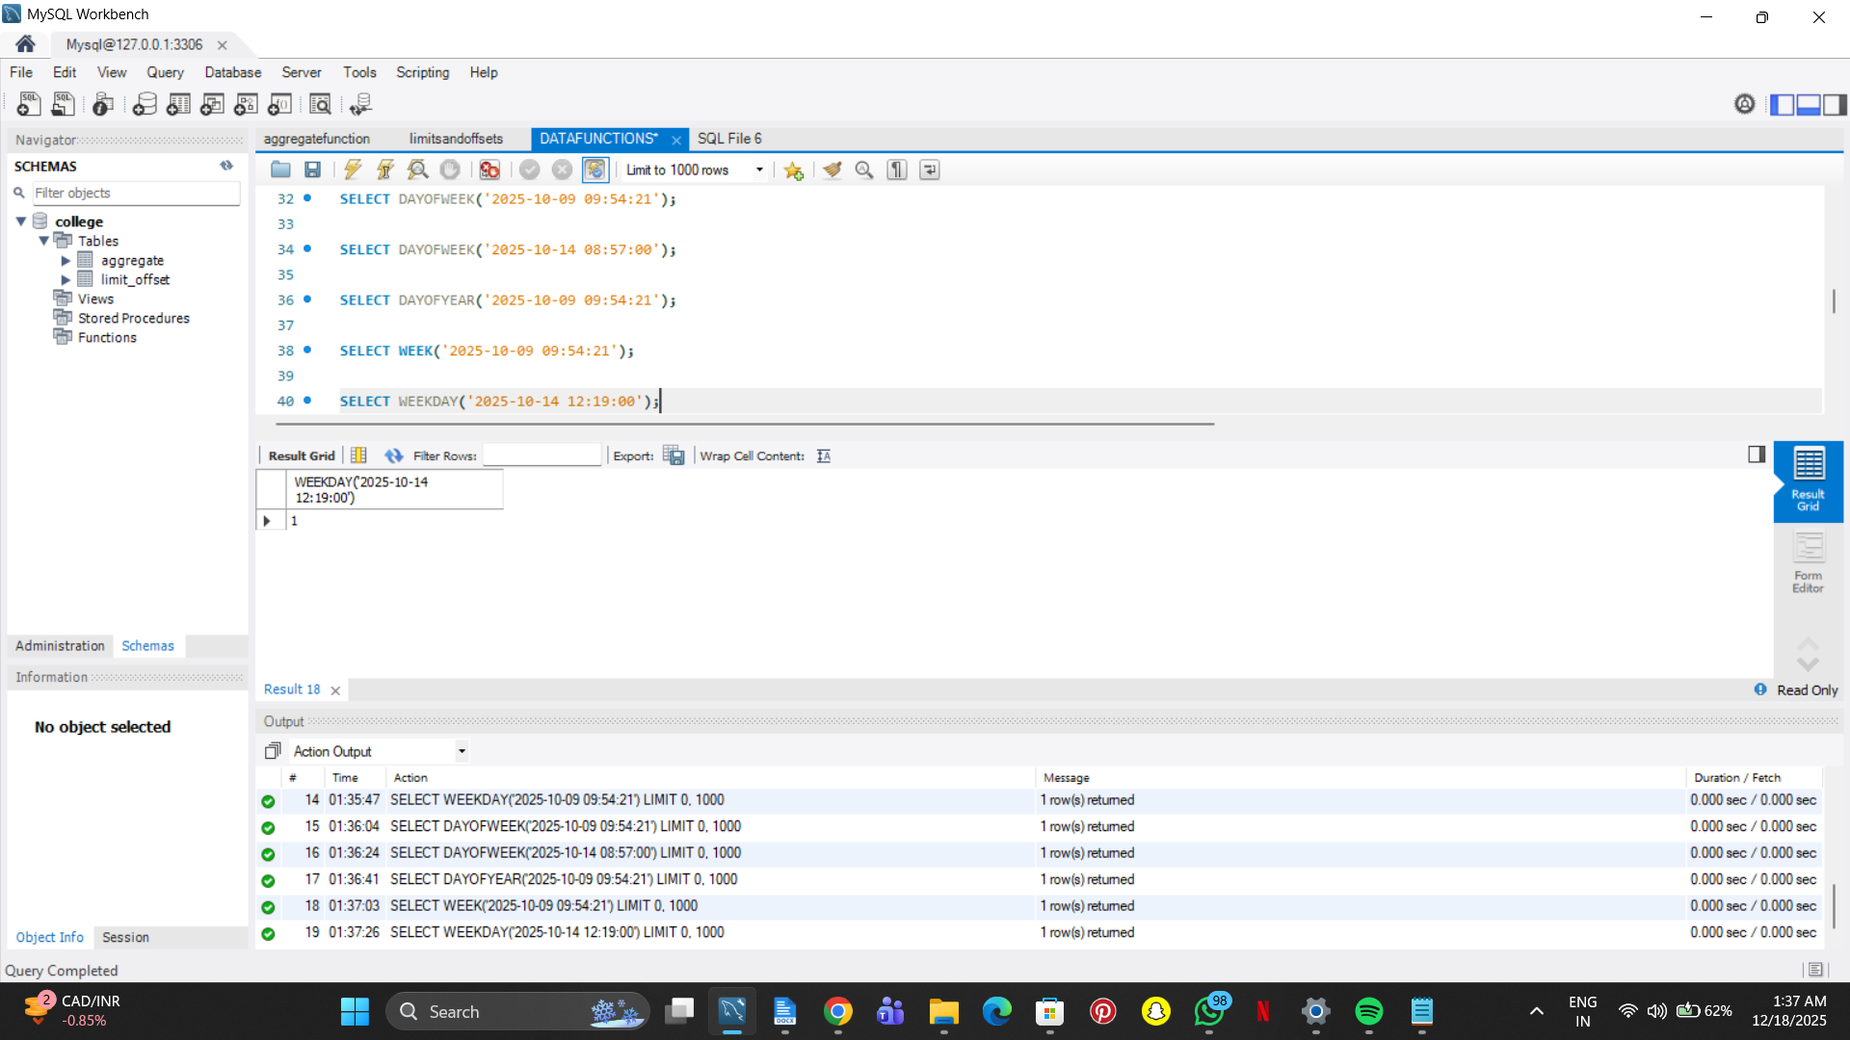

SELECT YEARWEEK('2025-10-09 09:54:21');

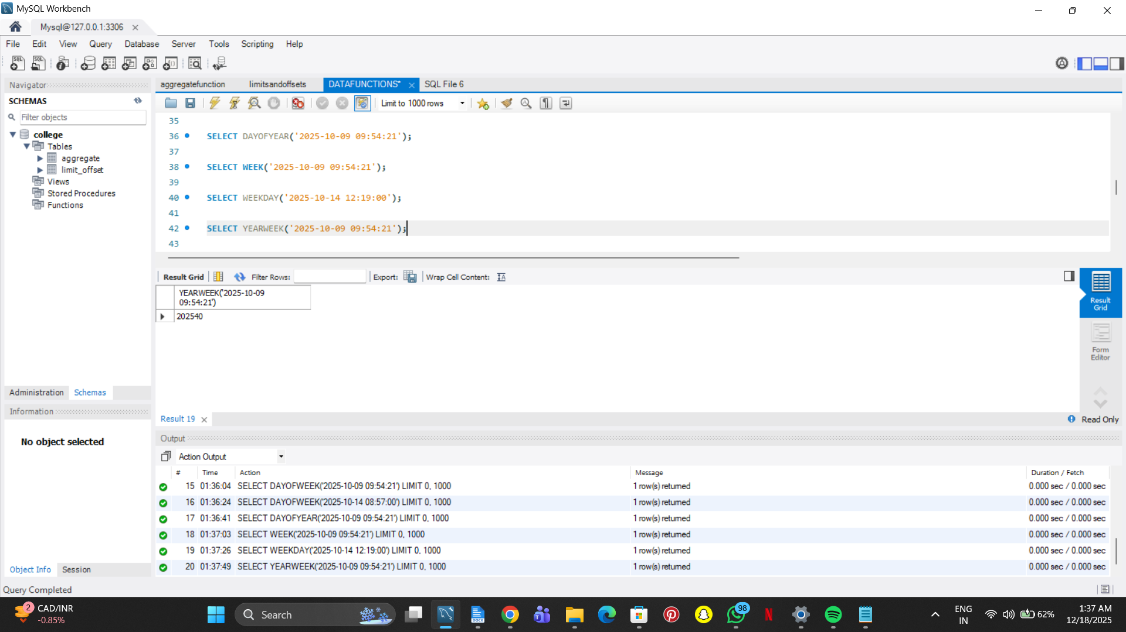

SELECT LAST_DAY('2025-10-09 09:54:21');

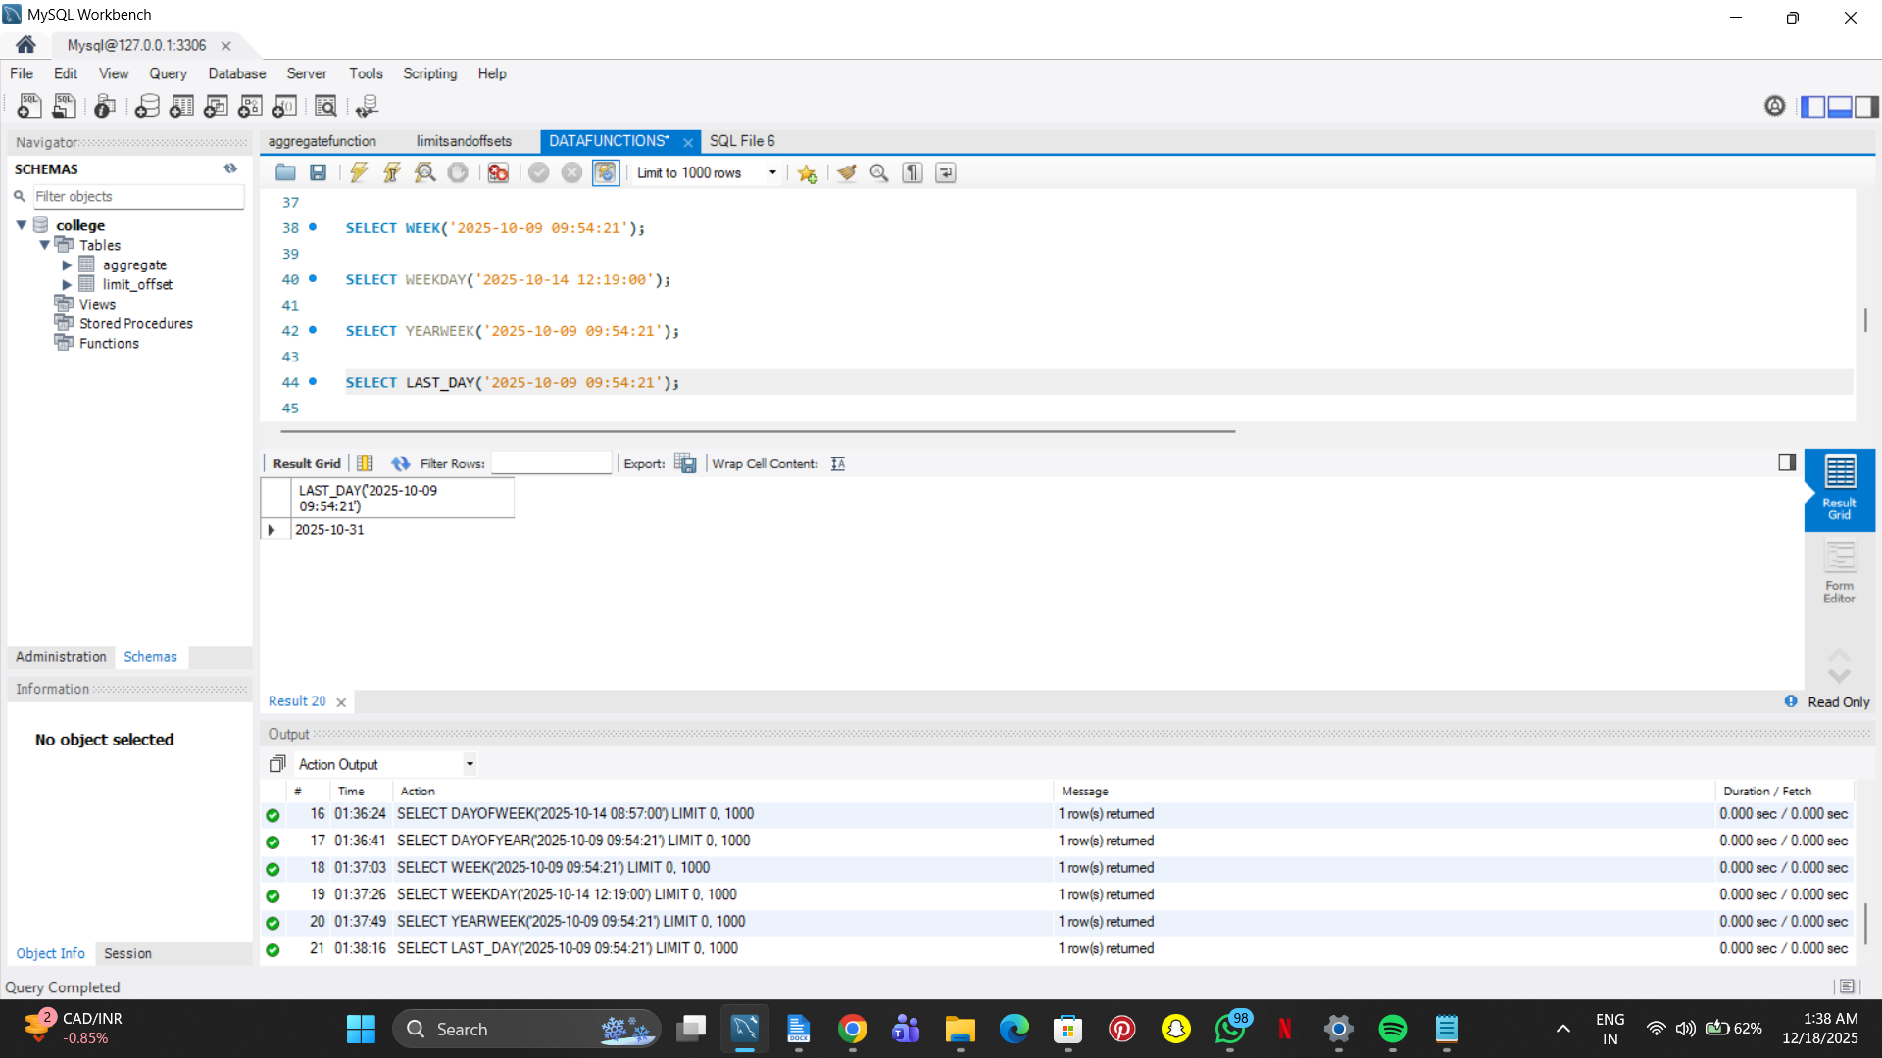

FROM '2025-10-09 09:53:21');

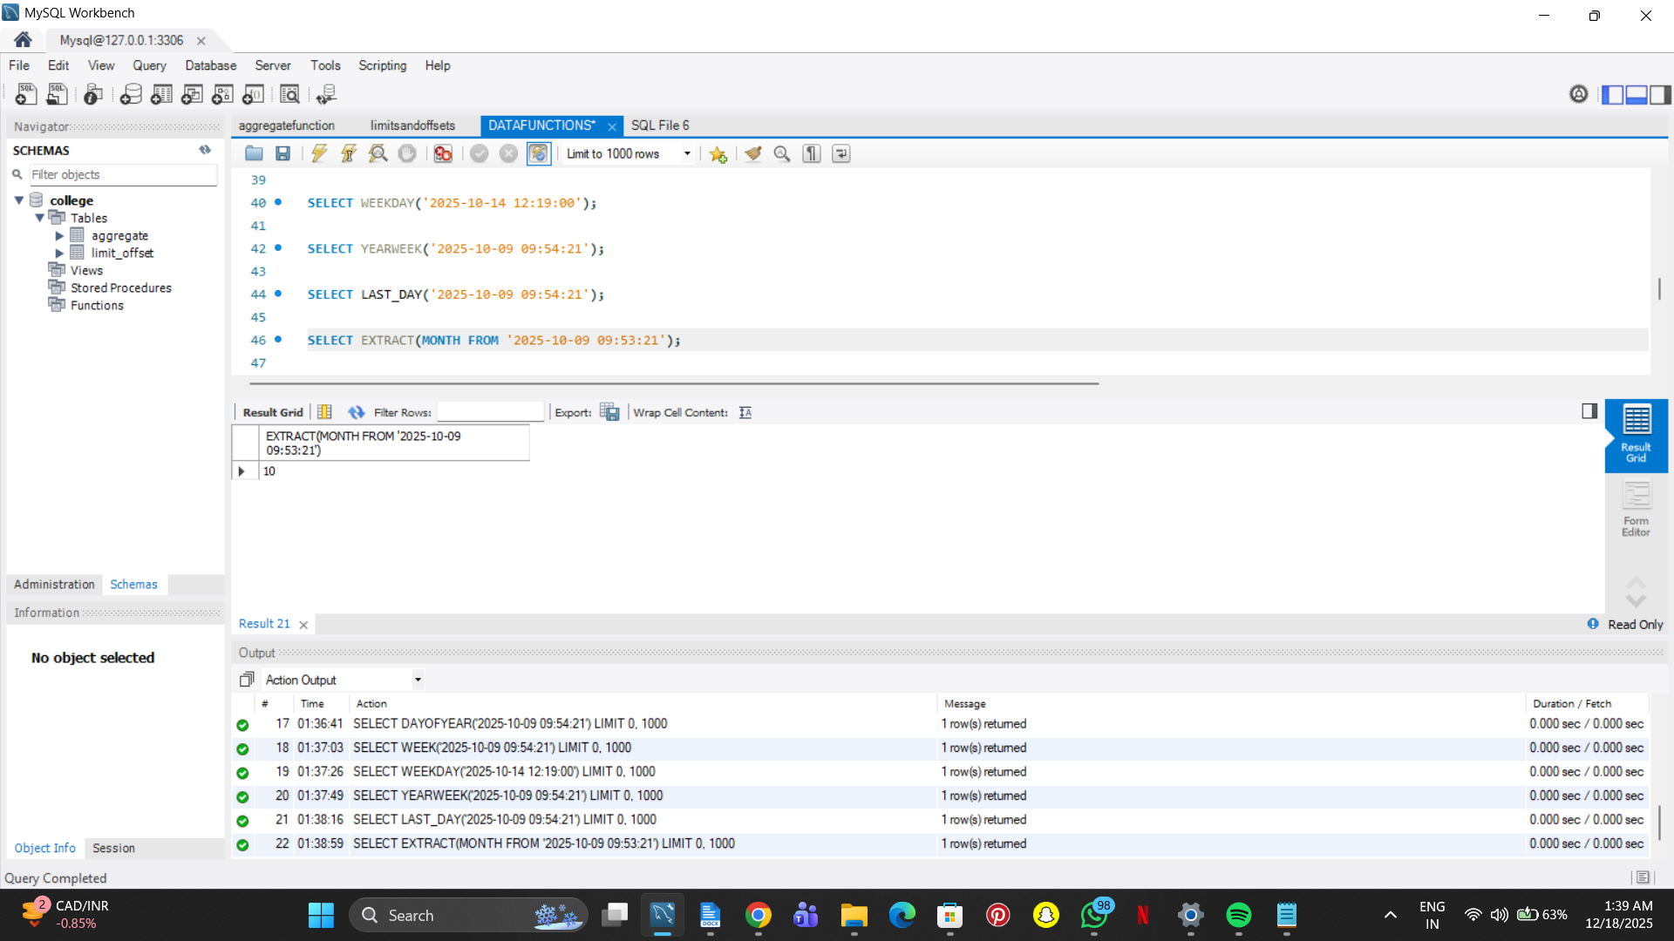

-- EXTRACT, ADDDATE, SUBDATE & DATEDIFF FUNCTIONS

SELECT EXTRACT(DAY FROM '2025-10-09 09:53:21');

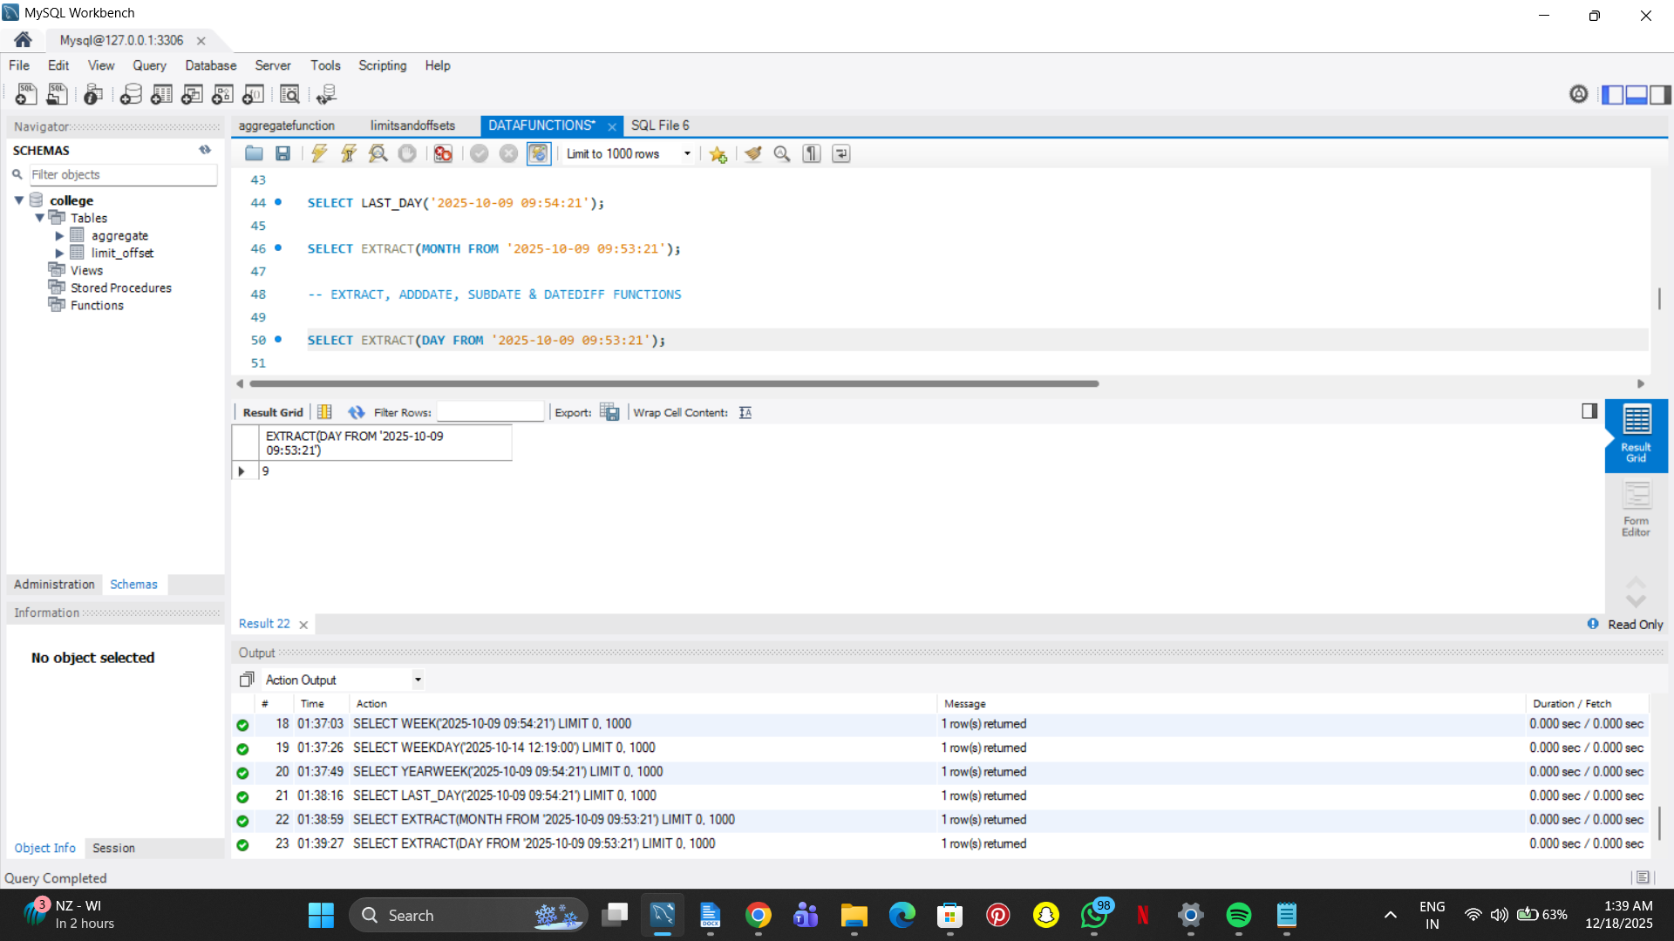

SELECT EXTRACT(DAY FROM '2025-10-09');

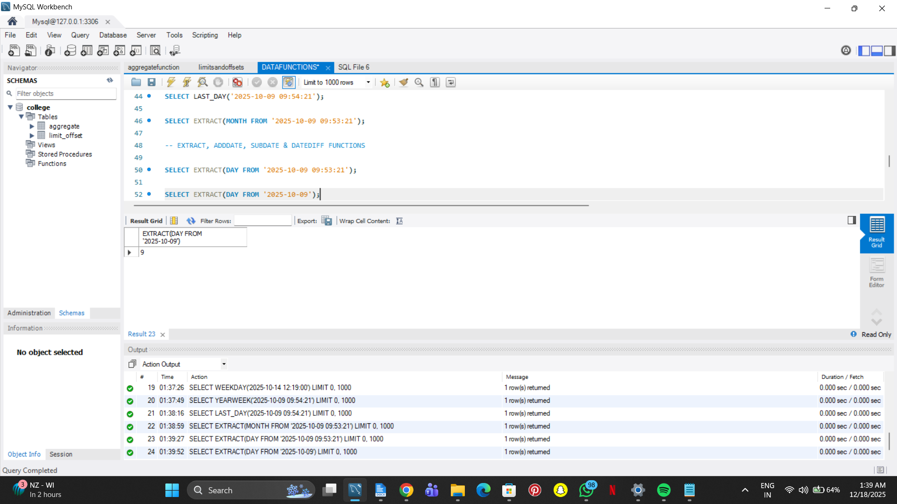

SELECT ADDDATE('2025-10-14', INTERVAL 10 DAY);

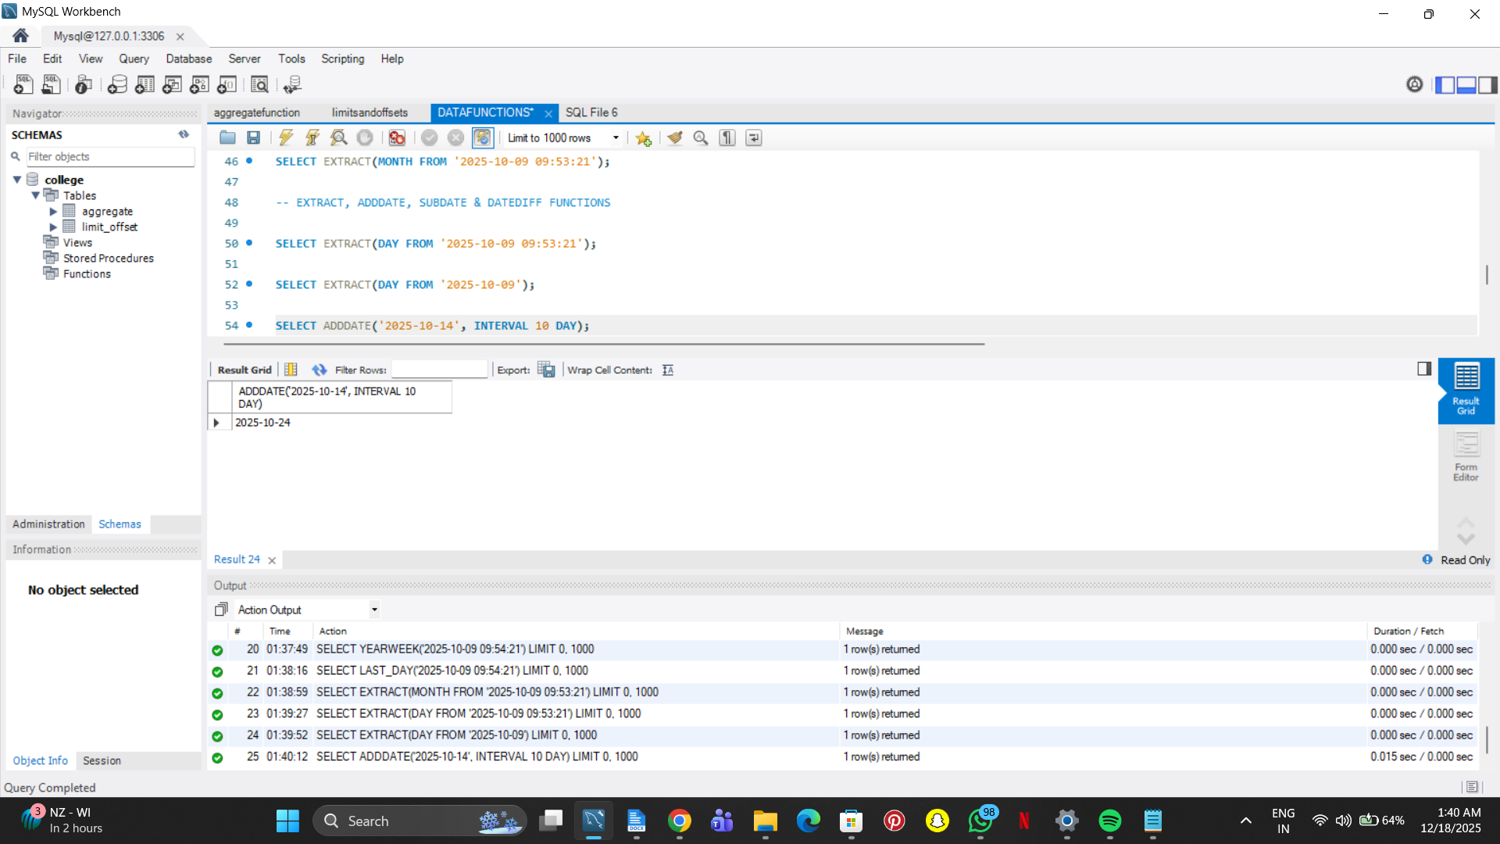

SELECT ADDDATE('2025-10-14', INTERVAL 1 MONTH);

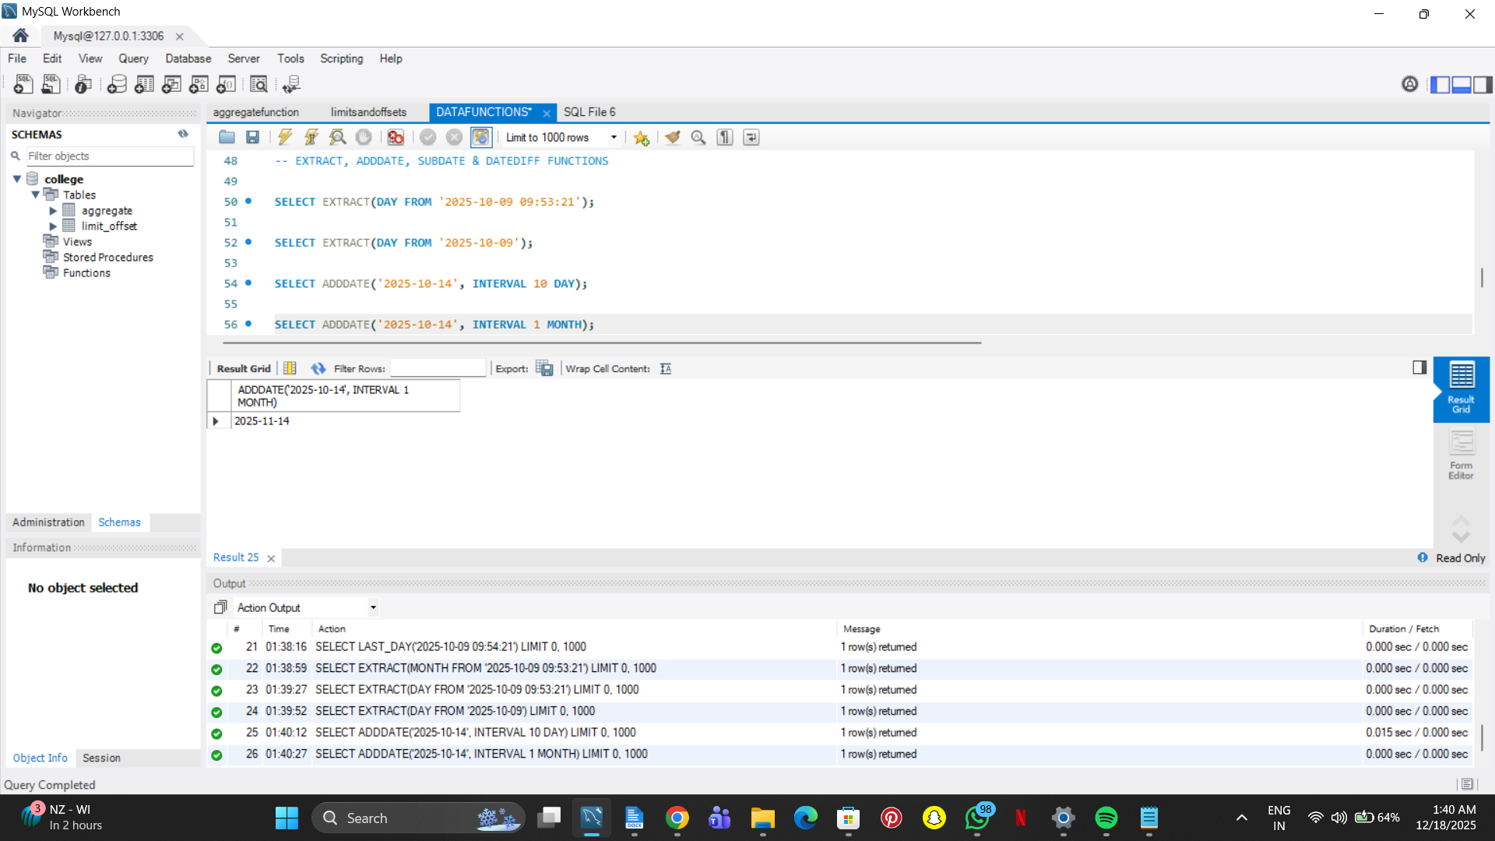

SELECT ADDDATE('2025-10-14', INTERVAL 1 YEAR);

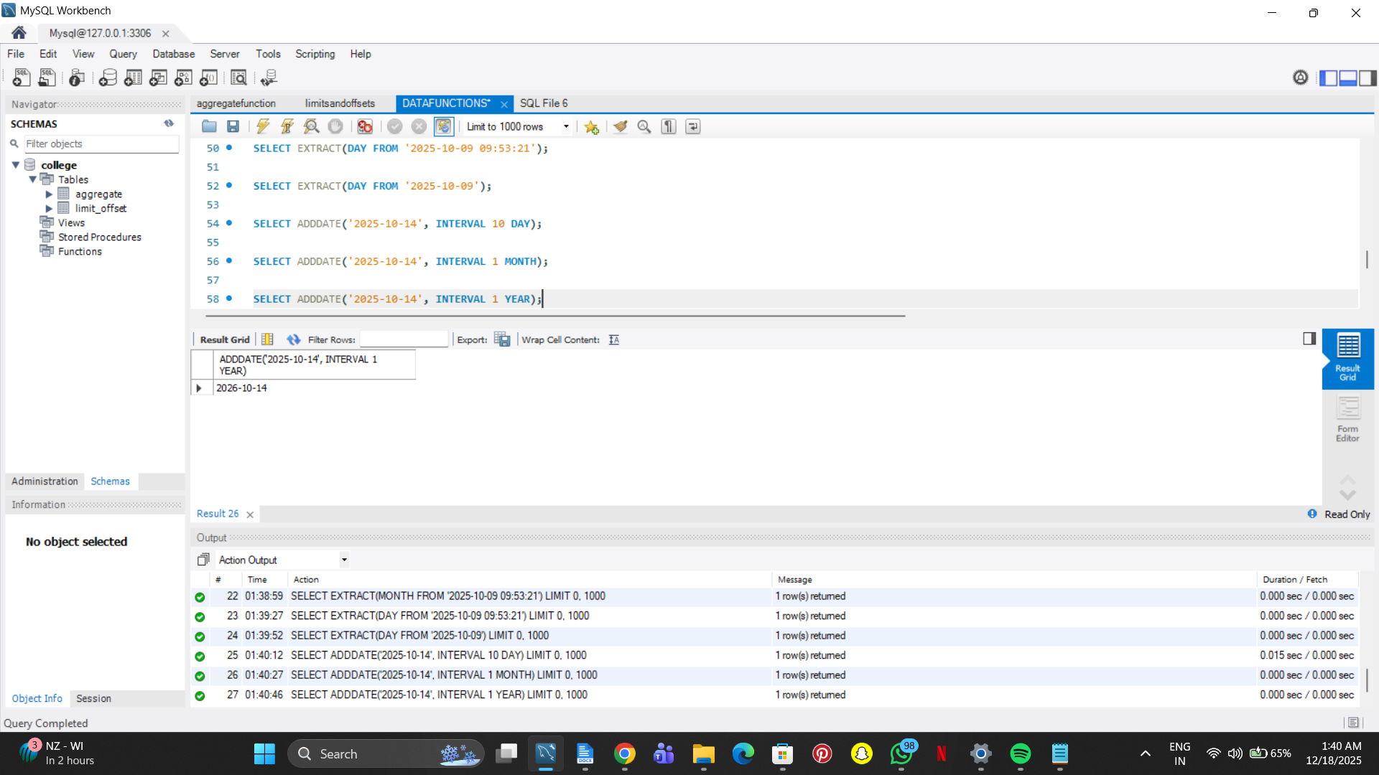

SELECT DATE_ADD('2025-10-14', INTERVAL 5000 MINUTE);

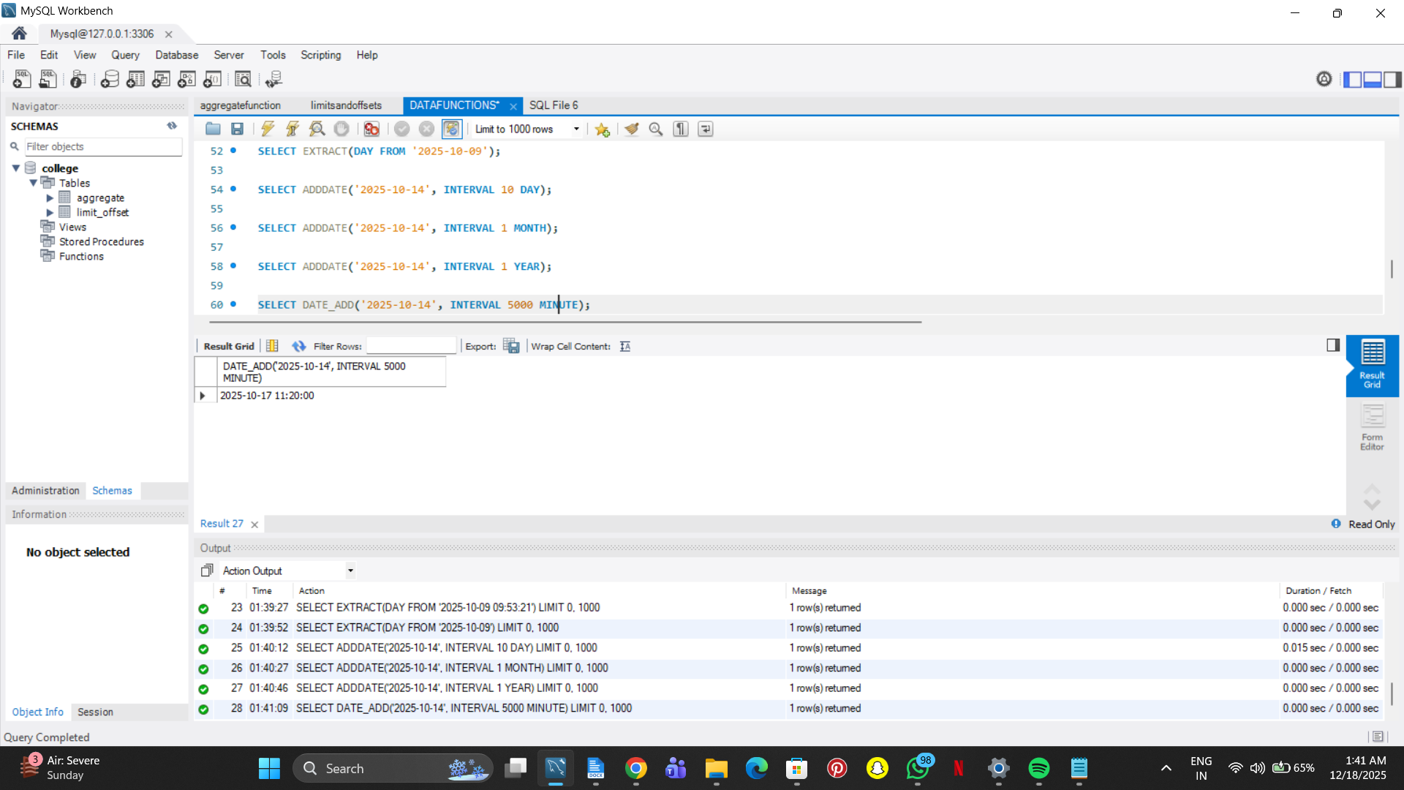

SELECT SUBDATE('2025-10-14', INTERVAL 1 MONTH);

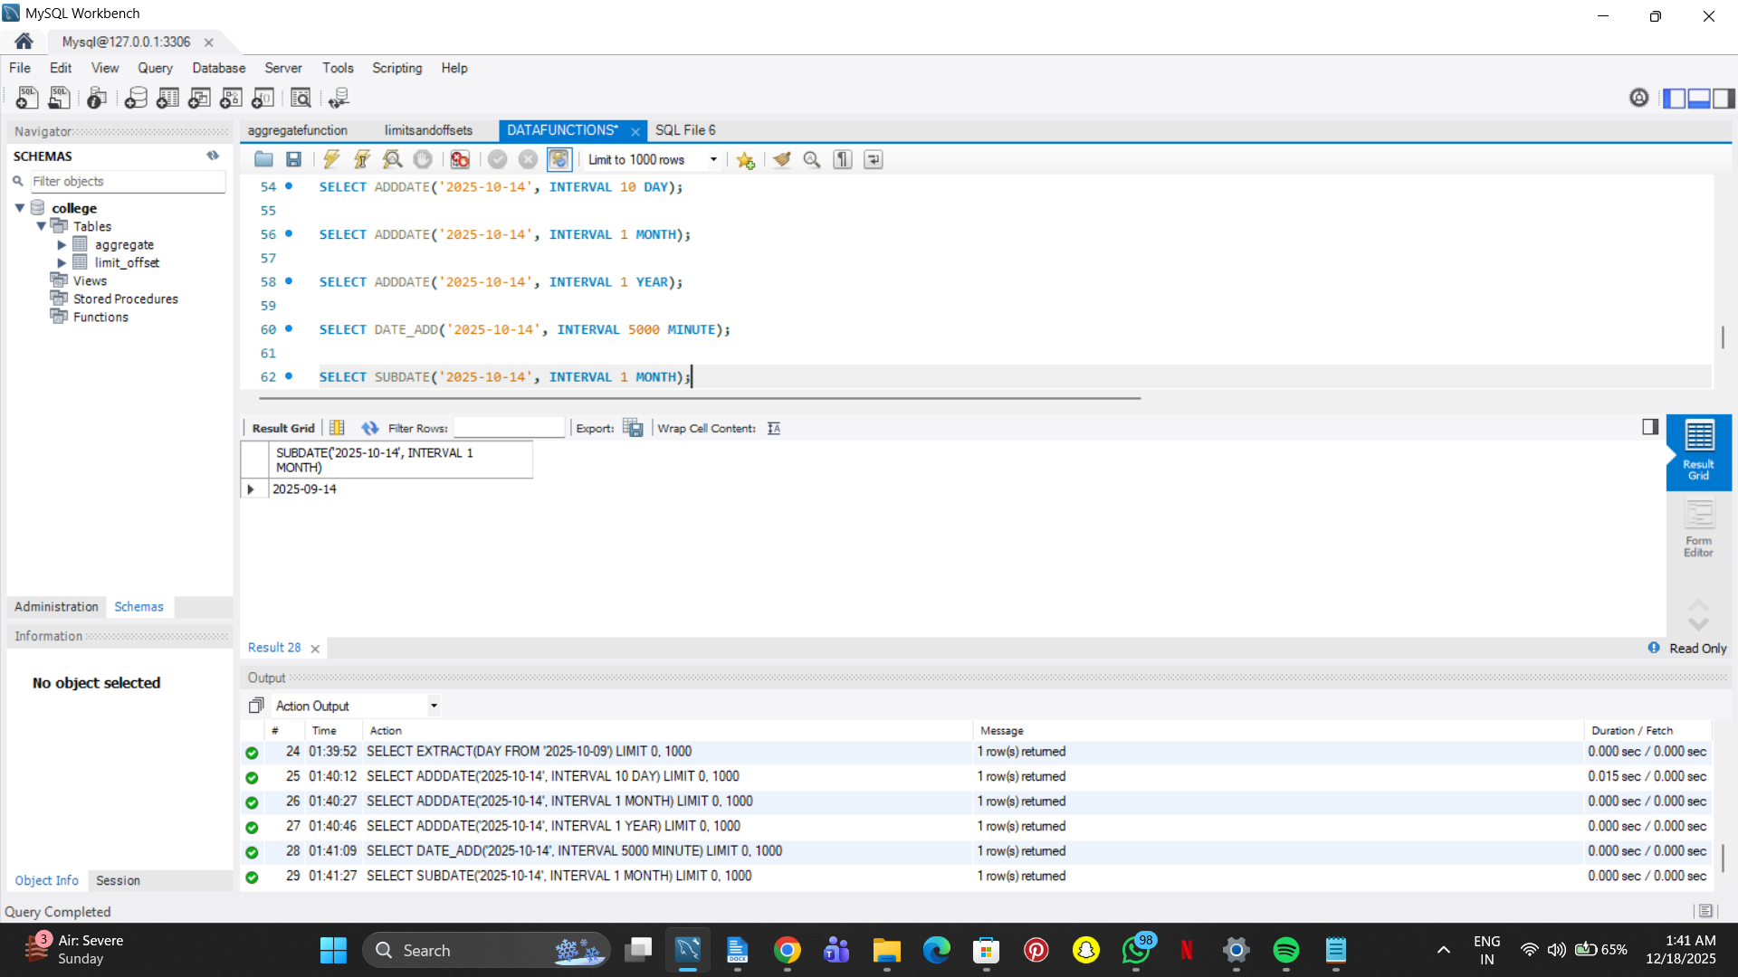

SELECT SUBDATE('2025-10-14', INTERVAL 1 YEAR);

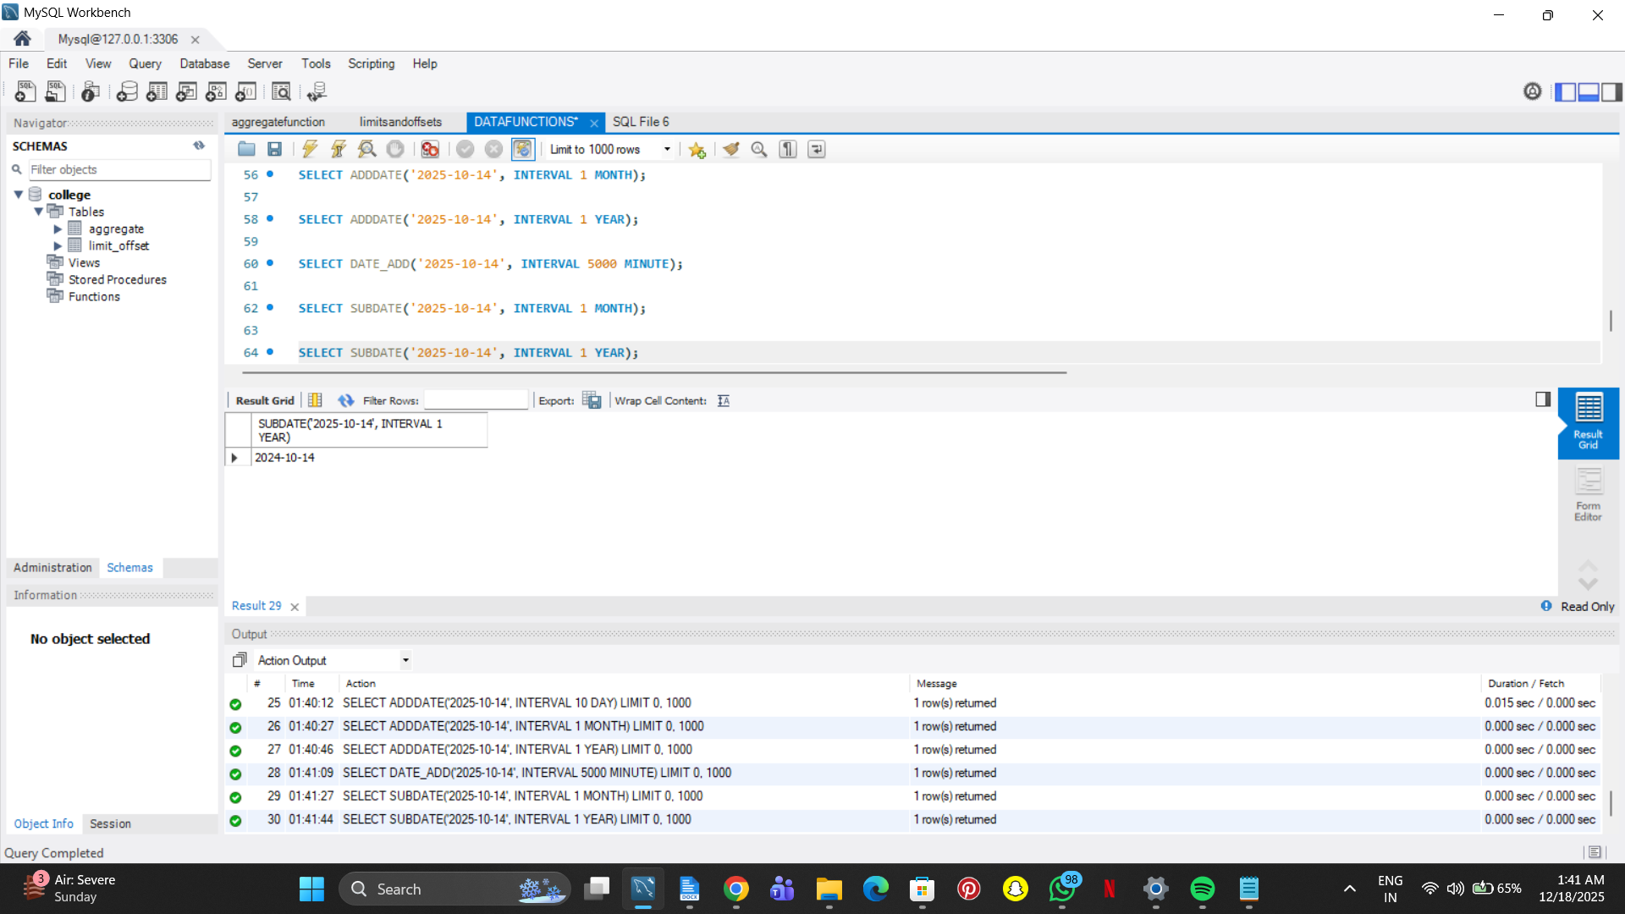

SELECT DATEDIFF('2025-10-14', '2025-09-14');

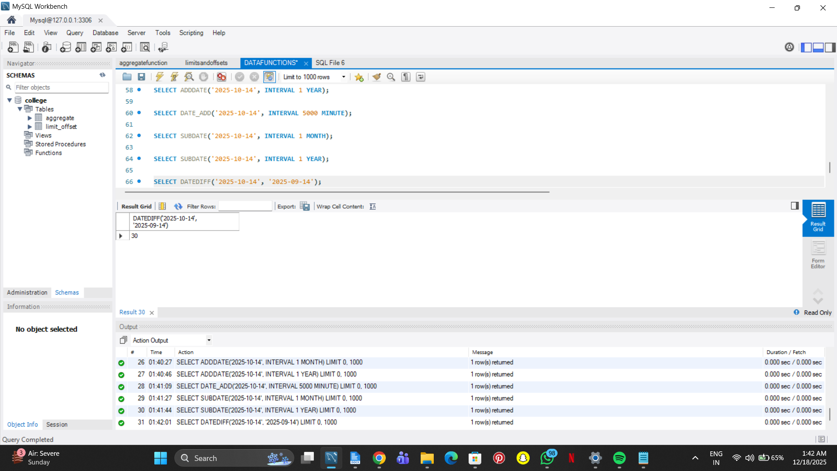

SELECT DATEDIFF('2025-10-14', '2024-10-14');

